LAB ASSIGNMENT - 3.1

NAME: Mohammed Faisaluddin
HTNO: 2303A52214
BATCH: 36

Question 1:
Zero-Shot Prompting (Palindrome Number Program)
Write a zero-shot prompt (without providing any examples) to generate a Python function that checks whether a given number is a palindrome.
Task:
- Record the AI-generated code.
- Test the code with multiple inputs.
- Identify any logical errors or missing edge-case handling.
CODE:
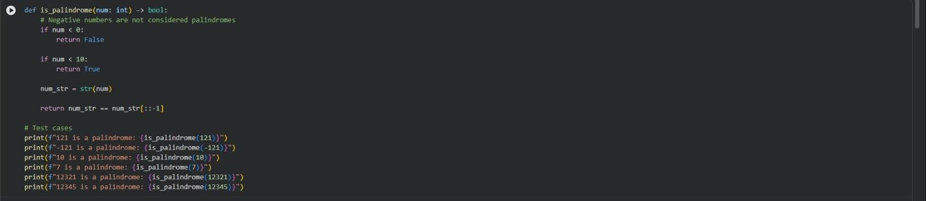
OUTPUT:
EXPLANATION:
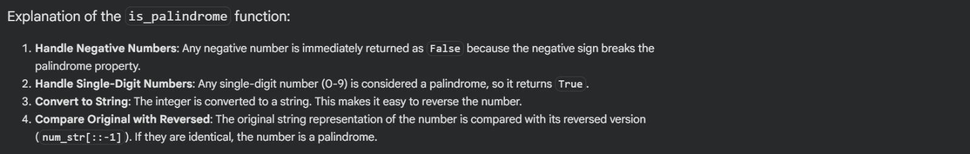
Question 2:
One-Shot Prompting (Factorial Calculation)
Write a one-shot prompt by providing one input-output example and ask the AI to generate a Python function to compute the factorial of a given number.
Example:
Input: 5 → Output: 120
Task:
- Compare the generated code with a zero-shot solution.
- Examine improvements in clarity and correctness.
CODE:
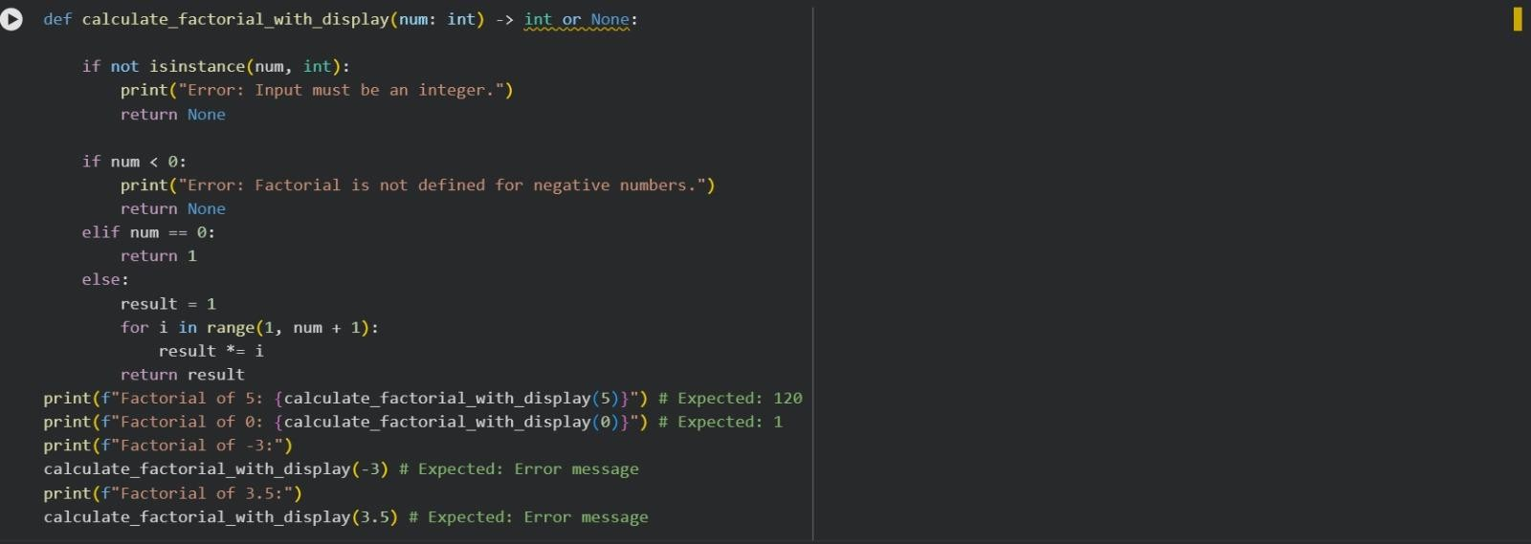
OUTPUT:
EXPLANATION:
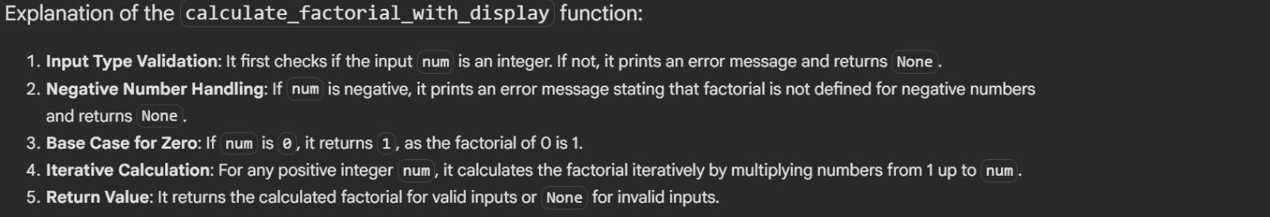
Question 3:
Few-Shot Prompting (Armstrong Number Check)
Write a few-shot prompt by providing multiple input-output examples to guide the AI in generating a Python function to check whether a given number is an Armstrong number.
Examples:
- Input: 153 → Output: Armstrong Number
- Input: 370 → Output: Armstrong Number • Input: 123 → Output: Not an Armstrong Number
Task:
- Analyze how multiple examples influence code structure and accuracy.
- Test the function with boundary values and invalid inputs.
CODE:
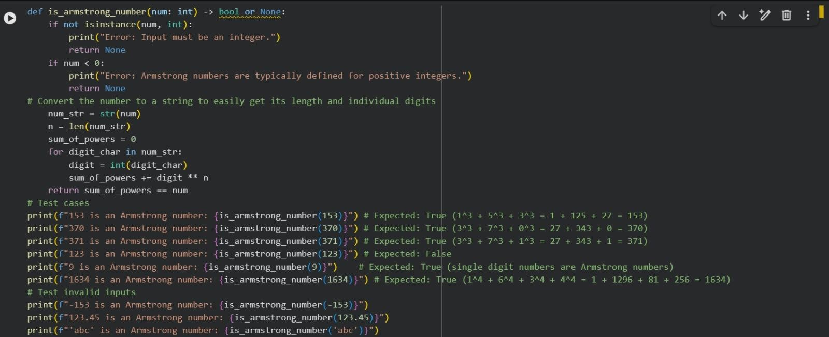
OUTPUT:
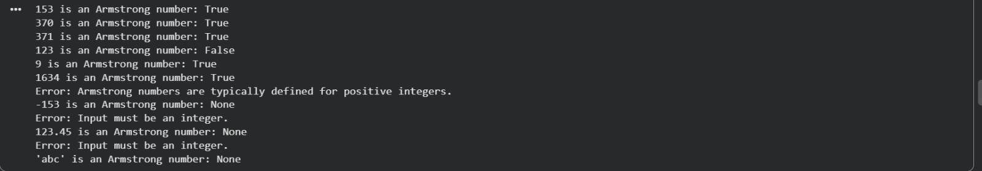
EXPLANATION:
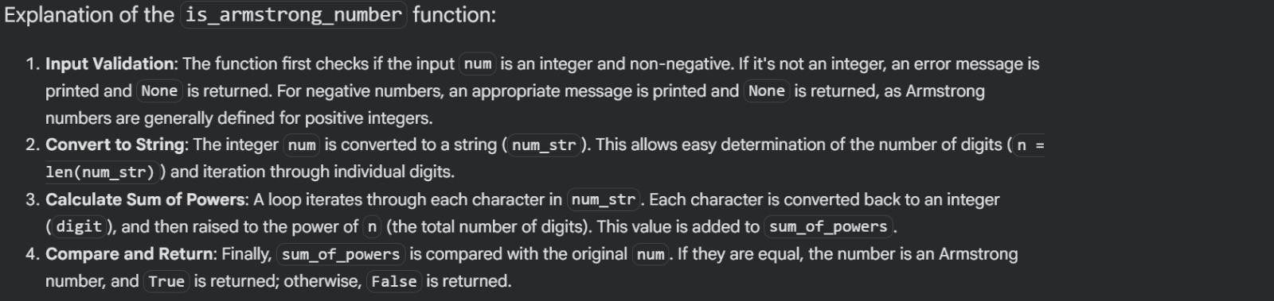
Question 4:
Context-Managed Prompting (Optimized Number
Classification)
Design a context-managed prompt with clear instructions and constraints to generate an optimized Python program that classifies a number as prime, composite, or neither.
Task:
- Ensure proper input validation.
- Optimize the logic for efficiency.
- Compare the output with earlier prompting strategies.
CODE:
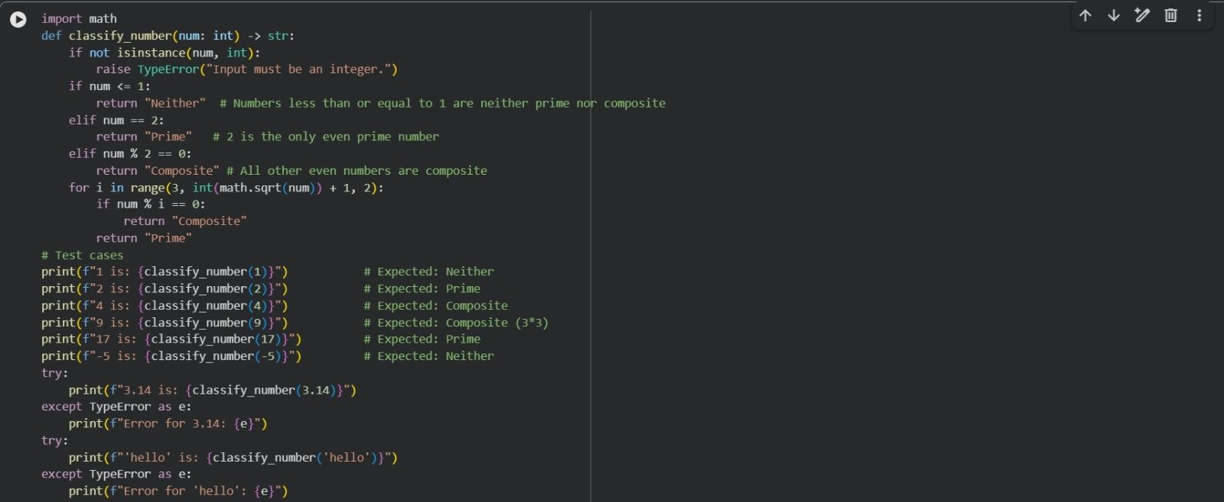
OUTPUT:
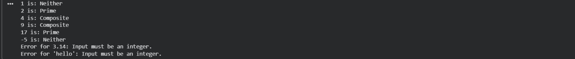
EXPLANATION:
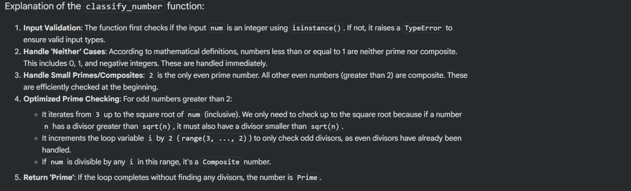
Question 5:
Zero-Shot Prompting (Perfect Number Check)
Write a zero-shot prompt (without providing any examples) to generate a Python function that checks whether a given number is a perfect number.
Task:
- Record the AI-generated code.
- Test the program with multiple inputs.
- Identify any missing conditions or inefficiencies in the logic.
CODE:
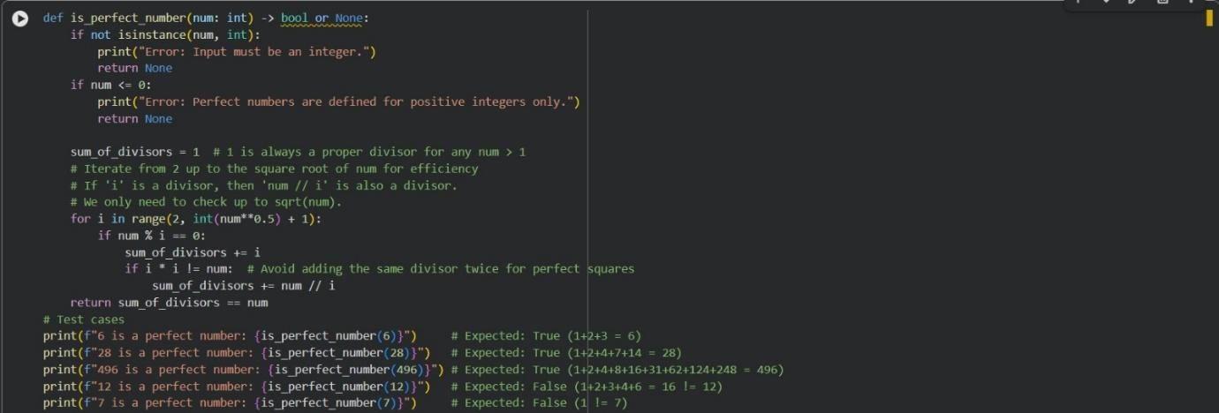
OUTPUT:
EXPLANATION:
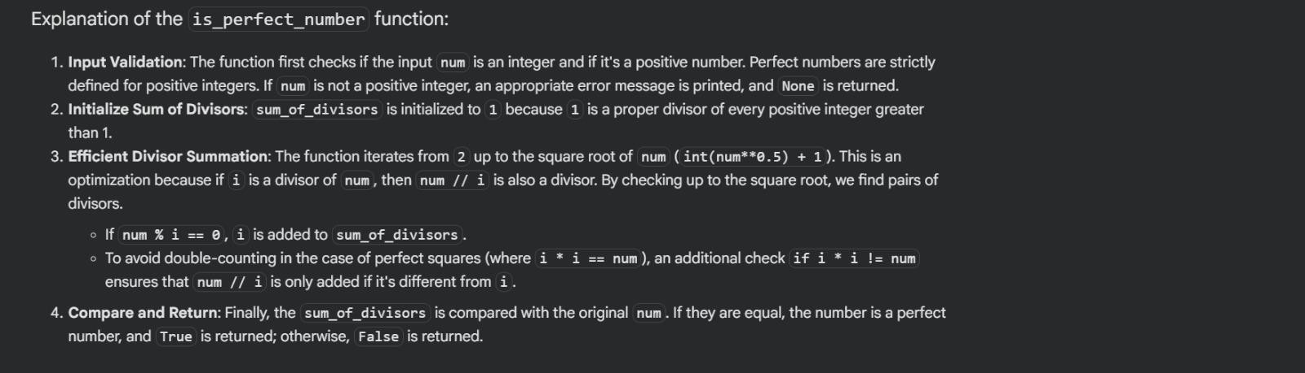
Question 6:
Few-Shot Prompting (Even or Odd Classification with
Validation)
Write a few-shot prompt by providing multiple input-output examples to guide the AI in generating a Python program that determines whether a given number is even or odd, including proper input validation.
Examples:
- Input: 8 → Output: Even
- Input: 15 → Output: Odd
- Input: 0 → Output: Even
Task:
- Analyze how examples improve input handling and output
clarity.
- Test the program with negative numbers and non-integer inputs.
CODE:
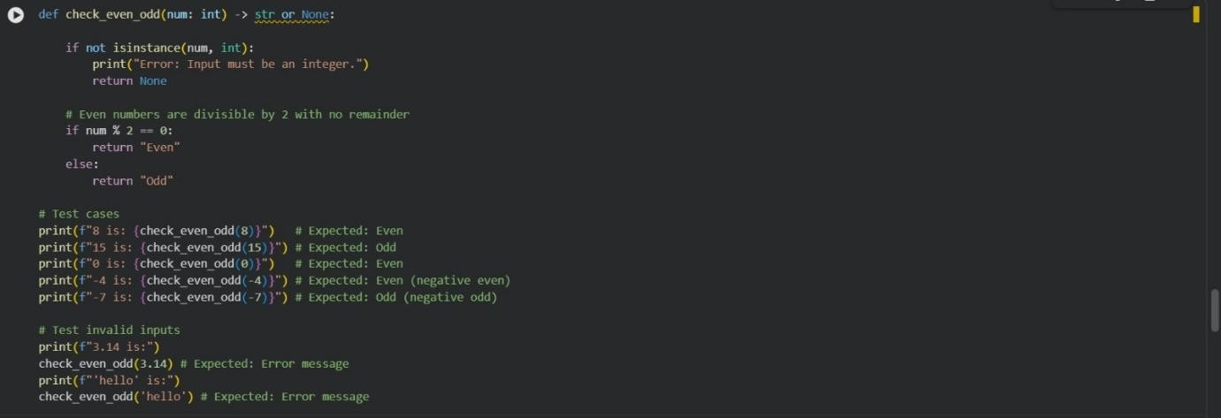
OUTPUT:
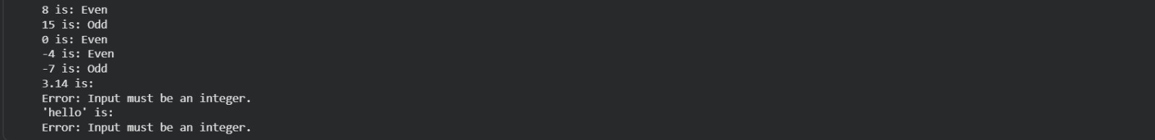
EXPLANATION:
